Childsoldiers
- Prior to 2002 the age limit for child soldiers was 15
- Approx. 300,000 children are in combat in some 30 conflicts around the world
- 40% of the world’s armies have children in their organized ranks

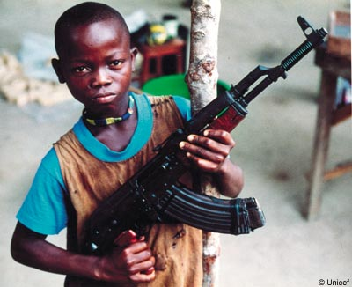
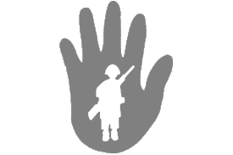
References

Kaplan, E. (2005, Dec 2). Child soldiers around the world. Retrieved from http://www.cfr.org/human-rights/child-soldiers-around-world/p9331

For more information please visit: http://supportinggirlchildsoldiers.weebly.com

By: Franceska Akel, Lizzy Pluta, Taylor Griffin, Emily Coblentz, and Andrea Boyd

Child Soldiers

Date of publication

Chiild soldiers
- When children are on battle fields it adds much confusion and also slows opposing forces
- Children have been used as messengers, scouts, mine sweeps, bomb-makers, and suicide bombers
- more than half of Burundi’s population is under 18, and the minimum age of recruitment is 16, yet children as young as 10 years old have played a significant role in conflict
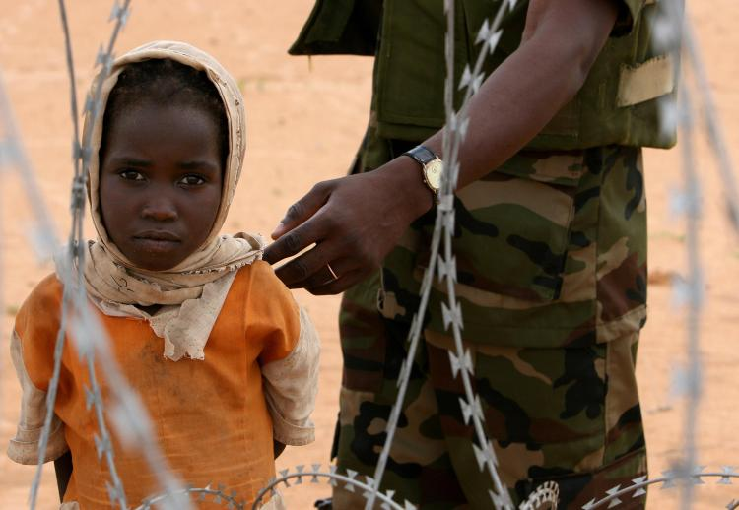

Girl soldiers
- 40% of child soldiers are girls
- Most of them are kidnapped
- They are used as the commanders “wife”
- Also they are used as sex slaves, porters, or cooks
- Some are used for suicide missions
- Girls are easy to catch when rebels go and try to find them
- girls are so small they can get into hard to reach places unlike men

Boy soldiers
- Children are used as soldiers because they are easy to condition and brainwash

- Many are forced to kill a family member

- It causes psychological and physical damage that can often never be repaired

- Without an education they can’t find jobs when the go home

- Not all children take part in active combat.

- Many children can't go back home to their families and communities because they've been ostracized from them.

